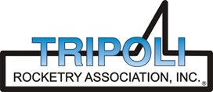
Tripoli Motor Testing Division
223 NC Highway 54 West
Chapel Hill, NC 27514
(919) 357 5681 (c)
May 6, 2023

Gary Rosenfield
RCS Rocket Motor Components, Inc.
2113 West 850 North Street
Cedar City, UT 84721

Dear Mr. Rosenfield,

The Aerotech H14ST-P motor was tested on May 6, 2023 and is in compliance with NFPA 1125. The motor is certified for hobby rocketry use by the members of the Tripoli Rocketry Association and all approving organizations with reciprocal certifying agreements.

Motor Manufacturer Aerotech Division, RCS Rocket Motor Components
Manufacturer’s Designation H14ST-P [DMS, single use]
Propellant Super Thunder
TMT Nomenclature 240 H13

Diameter 1.129” 28.66 mm
Overall Length 9.438” 239.71 mm
Length Inside 8.755” 222.38 mm
Length Outside 0.682” 17.33 mm

Loaded Mass 0.506 lb 229.47 g
Propellant Mass 0.296 lb* 134.1 g*
Burnout Mass 0.168 lb 76.06 g
* data provided by manufacturer

Burn time 18.255 ± 0.36 sec

Total Impulse 53.982 ± 1.37 lbf.s 240.12 ± 6.09 N.s
Max Impulse 9.352 ± 0.984 lbf 42.13 ± 5.22 N
Average Impulse 2.971 ± 0.117 lbf 13.21 ± 0.52 N
Number of Motors Tested 3

Nominal Measured
Delay Time Data n.a. n.a.

Casing Temp. [NFPA 1125 7.4.1] Passed

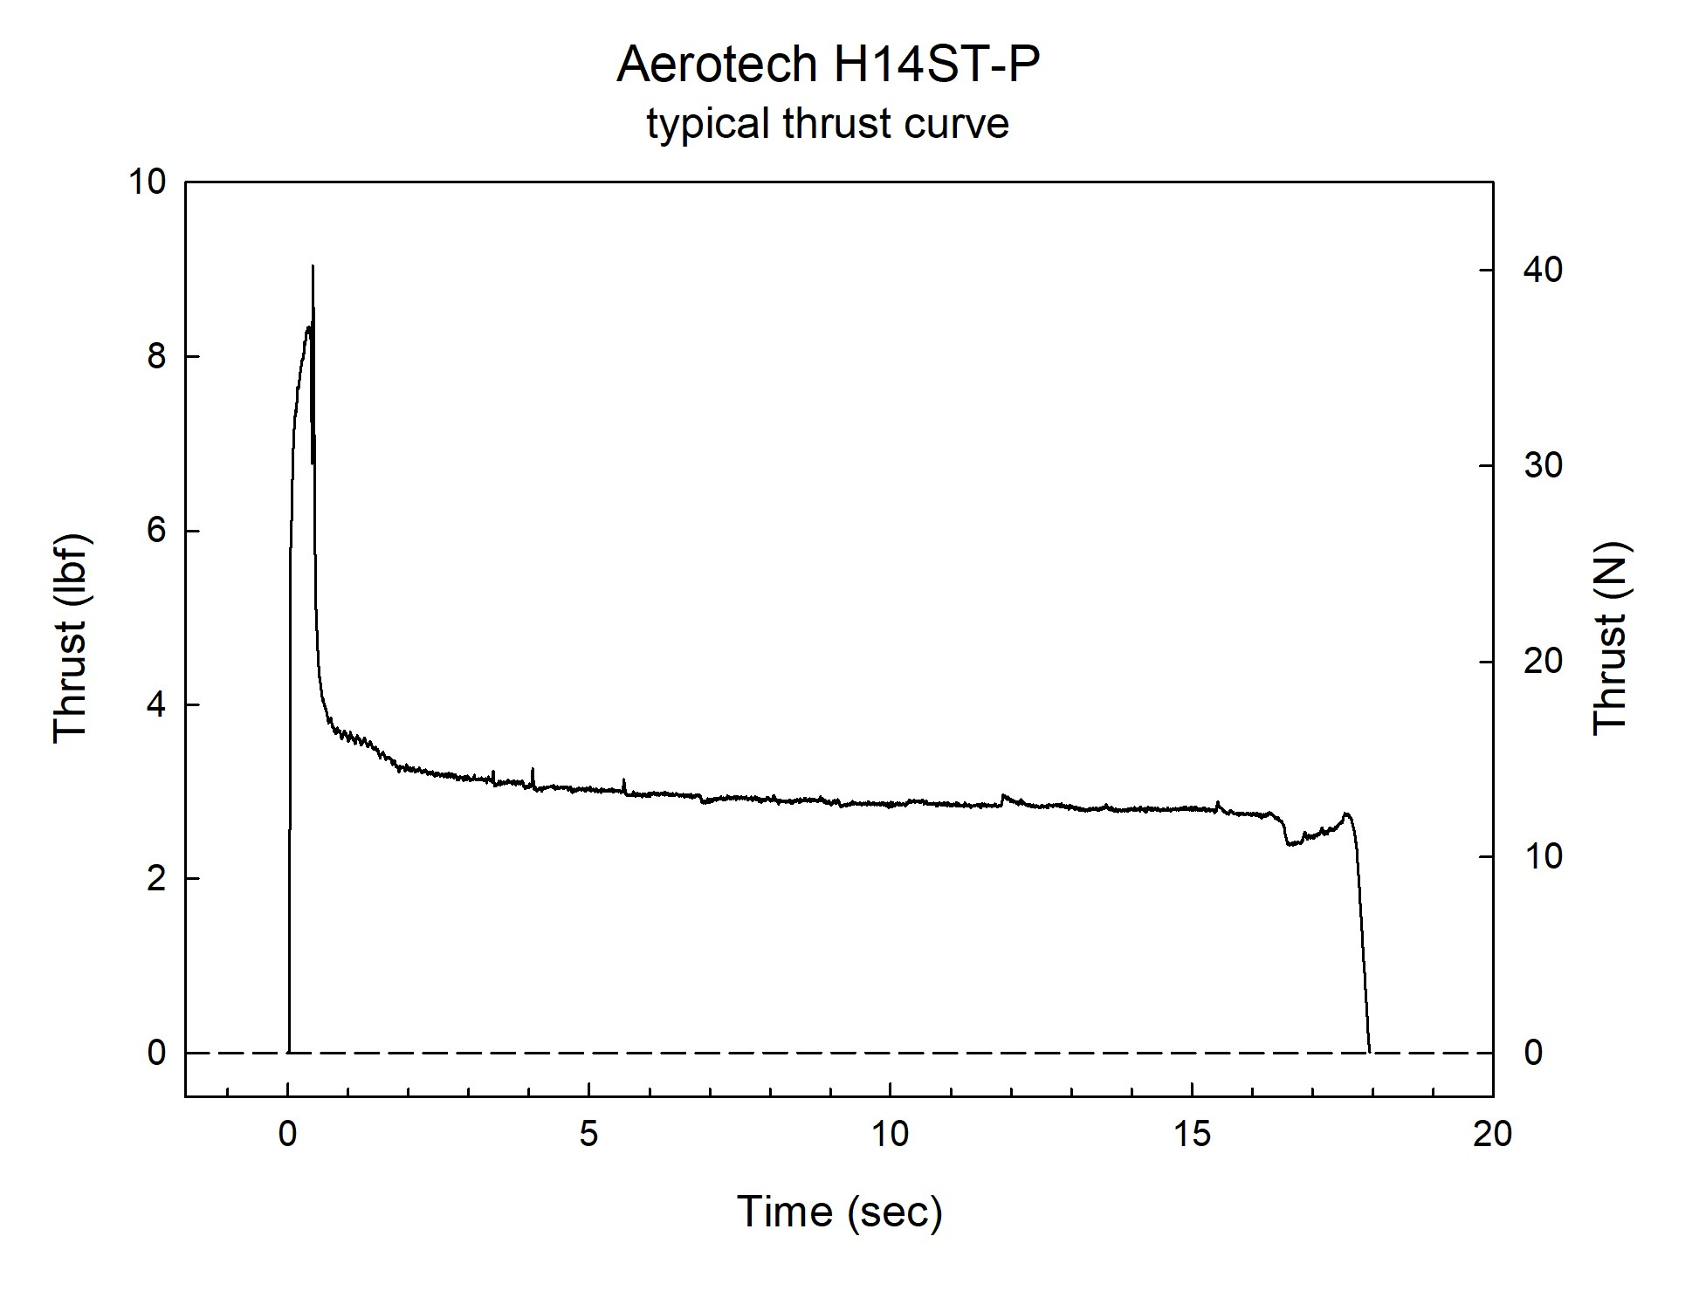

Sincerely,

Alan C. Whitmore
Chair, Tripoli Motor Testing

